Question 1
We answer this question based on a causal diagram presented in Figure 1. In this figure, the arrow between 'Eligibility' (the exposure) and 'Accumulated assets' (the outcome) represents the main causal effect we want to estimate. The other arrows between 'Income' (the common cause) and 'Eligibility' and 'Accumulated assets' represent the potential confounding influence of income on the relation between eligibility and accumulated assets, as described in the exercise description. In other words, income is assumed to have an impact on whether or not people are eligible for a 401(k) (i.e., 401(k) eligibility is affected by income, since higher-income jobs might be more likely to offer 401(k)s). In addition, income may also affect accumulated assets: the higher the income, the larger the number of accumulated assets.
Conditional exchangeability in this case means that the potential outcomes (e.g., accumulated assets if eligible or ineligible) are independent of exposure assignment (eligible or not) given the levels of income. In other words, when comparing study observations with the same value for income, the eligible and ineligible are exchangeable because the eligible, had they been ineligible, would experience the same average accumulated assets as the ineligible did, and vice versa. So, conditional on income, the effect of eligibility is not confounded by other variables that might affect both eligibility and assets (assuming income is sufficient to adjust for confounding).
Therefore, as income is assumed to be a common cause (or confounder) for both eligibility and accumulated assets, the variable 'income' should be included in further analyze to account for potential confounding bias.
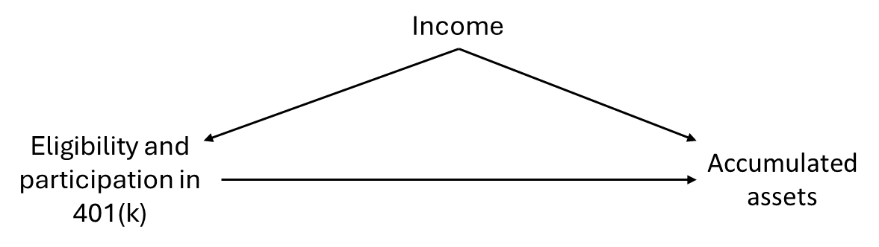
Figure 1: Causal diagram
Question 2
The R-code in attach presents the estimation of the ATE an ATT using both AIPW and TMLE. We used the SuperLearner package in R to create an ensemble model that combines several algorithms. Our complementary SuperLearner library ("SL.glm", "SL.gam", "SL.glmnet") includes a diverse set of algorithms that can capture different patterns in the data.
We start with the AIPW:
- The findings of the average treatment effect (ATE) indicate that the expected net financial assets are 7,952.23 dollars (95% CI [5,709.02 - 10,195.44]) higher for people who are eligible for enrolling in a 401(k) plan compared to those who are not eligible.
- The findings of the average treatment effect on the eligible people (ATT) indicate that the expected net financial assets are 10,692.13 dollars (95% CI [8,121.73 - 3,262.53]) higher in case people are eligible for enrolling in a 401(k) plan compared to not eligible.
Next, we present findings using the TMLE:
- The findings of the average treatment effect (ATE) indicate that the expected net financial assets are 8,343.30 dollars (95% CI [6,137.90 - 10,549.00]) higher for people who are eligible for enrolling in a 401(k) plan compared to those who are not eligible.
- The findings of the average treatment effect on the eligible people (ATT) indicate that the expected net financial assets are 10,873.00 dollars (95% CI [7,542.50, 14,204.00]) higher in case people are eligible for enrolling in a 401(k) plan compared to not eligible.
Finally, the unadjusted effect estimates are presented, based on a linear regression model. The findings indicate that the expected net financial assets are 19,559.30 dollars (95% CI [16,999.90 - 22,118.79]) higher for people who are eligible for enrolling in a 401(k) plan, compared to those who are not eligible.
The R code in attach also presents a check of the positivity assumption and extreme cases. For example, the validity of AIPW relies on the positivity assumption. In other words, if we have small overlapping between treated and control in the propensity score, then we get high variable ATE estimates with high standard error. However, this was not the case in this exercise.
Question 3
We used the efficient influence curve to estimate theta and its standard error. The estimated theta was 1,752.458 (SE = 251.286, z = 6.974, p < .001).
Question 4
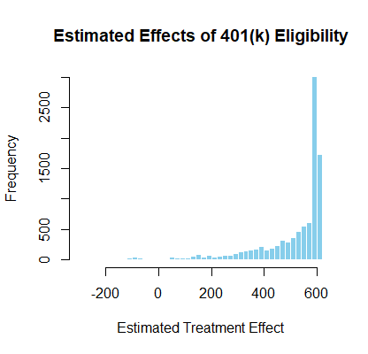
Figure 2: The histogram of the estimated effect of the 401k eligibility, obtained using the R-learner

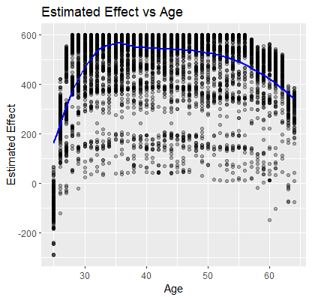  Figure 3: The estimated effect as a function of age, obtained via the R-learner | 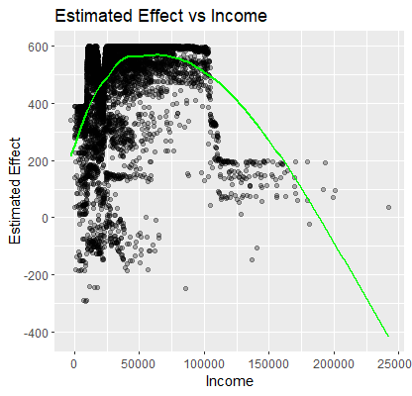  Figure 4: The estimated effect as a function of income, obtained via the R-learner | 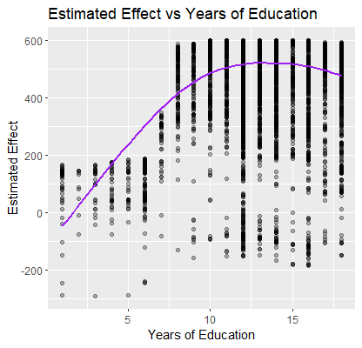  Figure 5: The estimated effect as a function of years of education, obtained via the R-learner
The histogram of estimated effects, which is illustrated in Figure 1, shows a strong right-skew. This indicates that the majority of individuals experience a positive treatment effect, clustering around 600 USD; though some individuals exhibit negative or near-zero effects. This suggests substantial heterogeneity in how people respond to 401k eligibility.
The effect heterogeneity is explored across age, income, and education. The estimated effect versus the age is illustrated in Figure 2. The estimated effect increases until about 35 years old, where it peaks. From there on out, until the retirement age, it decreases again. This suggests that people in the midst of their careers experience the greatest benefits from this, possibly due to other confounding variables.
Figure 3 illustrates the estimated effect as a function of the income. The estimation rises sharply up to about $30k, after which it’s pretty much stagnant until $90k. After this threshold, it starts to decrease again. Moderate-income individuals seem to benefit the most. Finally, the estimation versus education is looked at in Figure 4. The treatment effect increases until about 12 years of education and remains stagnant afterwards. People who had more years of education, benefit more from 401 plans.
Eligibility for a 401 plan has a positive average effect on net financial assets, but the impact varies considerably based on individual characteristics. The highest benefits are observed among middle-aged, moderate-income, and better-educated individuals, reinforcing the importance of tailoring retirement incentives to demographic subgroups.
Question 5
The histogram of the prediction of the counterfactual net financial assets that would be observed when being eligible for enrolling in a 401 (k) plan is shown in figure 6. We see that this histogram has a long tail, which means that there are some people who have substantially more net financial assets than the average person. The counterfactual net assets as function of age, income and years of education is shown in figures 7-9. These figures show the expected trend of the net financial assets.
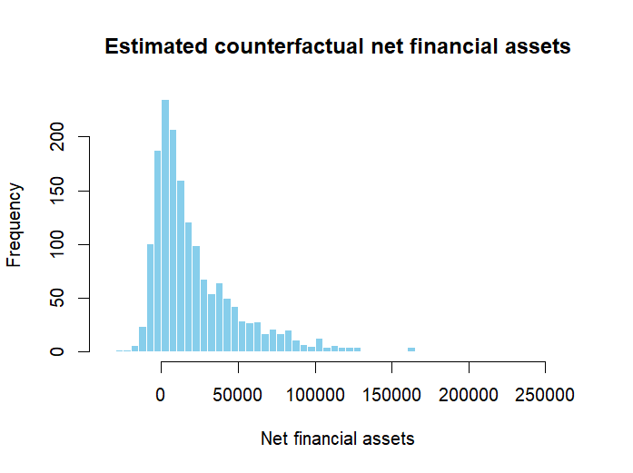
Figure 6: The histogram of the estimated counterfactual net financial assets, obtained using the DR-learner

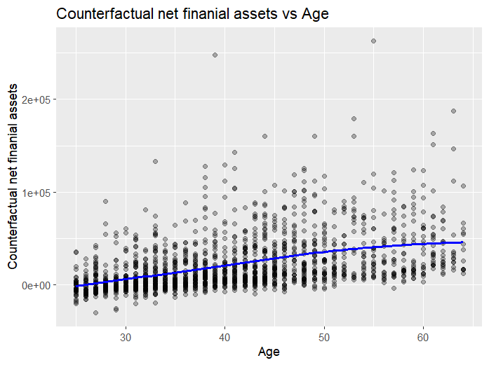  Figure 7: Counterfactual net financial assets as a function of age, obtained via the DR-learner | 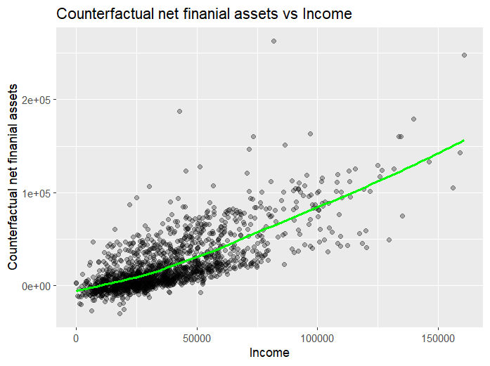  Figure 8: Counterfactual net financial assets as a function of income, obtained via the DR-learner | 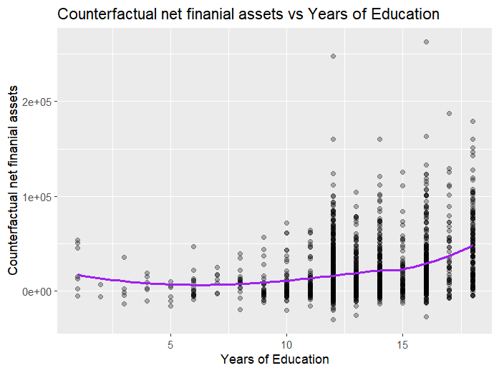  Figure 9: Counterfactual net financial assets as a function of age, obtained via the DR-learner
The counterfactual prediction error can be estimated by making use of the AIPW estimators efficient influence curve. This is given by;
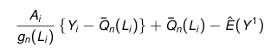
The first terms can be identified as the pseudo-outcome of the DR-learner. The last term can be calculated by performing the AIPW algorithm. The standard error can now be calculated as 1 over the square root of N times the standard deviation of the efficient influence curve. We find a standard error of $1410. The 95% confidence interval for the counterfactual net financial assets is given by [$17 322, $22 852].
Attachment
The structured R code is submitted as a separate file.
Contributions
Dries De Weerdt: Questions 1-3; Check answers of question 4-5.
Mikel Nachtergaele: Question 4; Check answers of question 1-3, 5.
Jonas Vanhauwe: Question 5; Check answers of question 1-3, 4.

